|  |  |  |  |  |  |  |
| --- | --- | --- | --- | --- | --- | --- |
| C:\Users\Jerick\AppData\Local\Microsoft\Windows\INetCache\Content.Word\gcstransparentLOGO.PNG | **GCS Dashboard** | |  | | |  |
| **Change text to: “Total Project Size KWAC”** | | **Change Text to: “Total Current Power”** | | Add Average Irradiance, w/m2 | **Change Text to: “Production, Performance %”** | |
|  | |  | |  |  | |
|  | |  | |  |  | |

Change color of boxes to colors below.

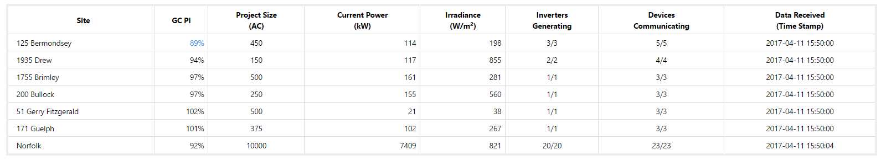

Add option to sort by:

1. AC Size, or Site Name (Alphabetical Order)

Add Comma to 10,000.